Problem Set 1 BB2920 – Genetics C-2017 Due **in class** Friday 1/20/17

**Problem 1 (30 points)**

You are working on an off-campus MQP in the Galapagos, and are taking a break from your studies for a stroll down the beach when you notice a particularly unique-looking tortoise. The little tortoise seems pretty friendly, so you scoop it up and bring it back to the lab to show your advisor. Your advisor examines the little tortoise with great interest, and informs you that you may have just identified a new tortoise species!

Excited, you head back to the beach to track 100 individuals of the species and make notes on their physical traits.

Describe an example of **(a)** continuous variation and **(b)** discontinuous variation in the phenotypes of your new species. Draw a graph and include an explanation of your observations.

(Notes: Yes, I want you to just make up the data for the phenotypes and the graph! Be creative! I expect lots of *DIFFERENT* responses, as there are pretty much an infinite number of possible phenotypes you could make up. Please don’t consider the animals’ sex; assume you cannot tell male from female by a simple visual inspection. Also you can’t use the examples in parts e or f. C’mon! Make up something else! )

Graphs should have a clearly labeled title, axes, and units, and the data should add up to 100 individuals.

**10 points per graph. Axes should be labeled and a brief description indicating the phenotype as continuous or discontinuous should be included.**

**make sure that their graphs add up to 100 individuals! -2 points per graph if it doesn’t add up to 100. -2 points if axes are unlabeled or unclear. If continuous and discontinuous are reversed, but the graphs are otherwise correct, give half credit.**

1. **continuous: many states on a continuum, generally controlled by many genes. Example: shell diameter, may be anywhere from very small (~1 cm) to very big (> 20 cm) with most individuals around the middle (8-12 cm). Graph should contain several categories over a broad range.**
2. **discontinuous: only two or a few states (eg. black spots on shell present or absent, skin warty or smooth, eyes black or brown, whatever). Should be a bar chart where the individual traits = 100 (eg. 75 w/ warty skin, 25 w/ smooth) the exact numbers don’t matter as long as they = 100.**

You manage to obtain a small tissue sample from the tail of one (very angry!) tortoise, and you prepare a karyotype from the cells. You find 52 chromosomes. How many chromosomes would there be in:

**(c)** a normal somatic cell? **Somatic = 52 (2 points),**

**(d)** a gametic cell?

**gametic = 26 (2 points)**

**(e)** You do some additional analysis on the DNA sample to examine the structure of the tortoise’s chromatin. After digestion of the DNA sample with a nuclease, the DNA appears to have separated into 120bp fragments attached to a core of histone proteins. Further analysis of the histone core reveals histones in the following proportions:

H1 12.5%

H2A 25%

H2B 25%

H3 0%

H4 25%

H7 (a new histone) 12.5%

On the basis of these observations, what conclusions could you make about the probable structure of the nucleosome in this tortoise species?

**This species has a nucleosome made of 8 histones: one H1, two each of H2A, H2B, and H4, and one H7. This nucleosome then has 120bp of DNA wrapped around it. (4 points)**

**Note: in class, we talked about H1 being on the outside of the histone core. In this case, the students may say that in this organism, H1 is part of the octamer of proteins in the core, or they may say that this organism has a core made of up only seven histone proteins, and perhaps H7 is just really large, or (if they are really astute) they may note that this histone core is smaller (only 7 histones in the core) because it wraps less DNA than a human histone (this one wraps 120nt, and human histones are ~146bp). Be very generous on this question. Its ok if the students are hypothesizing a bit. If they are totally lost and don’t know what to write, encourage them just to compare this new nucleosome to the human histone we discussed in class, and not how its different. That will be sufficient for credit.**

**(f)** You notice that while most of your tortoises have dark brown spots on their shells, a small number have no spots at all. You send DNA samples from spotted and spot-less individuals back to WPI for DNA sequence analysis, and discover that the spot-less individual is missing a large portion of a gene that encodes the pigment melanin. That explains the absence of the spots! Would your approach to studying this tortoise phenotype be considered an example of forward or reverse genetics? Briefly explain.

**forward genetics, starting with a phenotype and looking for the genotype. (2 poins)**

**Problem 2 (15 points)**

You have a 1.4 kb DNA fragment that contains exactly 730 adenine nucleotides.

Show all of your work for the calculations below: [5 points for each response]

**(a)** What ***percentage*** of total nucleotides are guanine?

**There are 1400 base pairs, which is 2800 total nucleotides. 730 are A, so 730 are also T. This leaves 1340 Gs and Cs, so 670 Gs and 670 Cs. 670/2800 = 23.93% (approx.. 24%) G nucleotides. [5 points, Deduct 2 if the answer is given as 670 Gs and not as a percentage. Otherwise no partial credit]**

**(b)** Exactly how many hydrogen bonds hold the two strands together?

**(730 A-T pairs with 2 H-bonds = 1460 bonds) + (670 C-G pairs with 3 H-bonds = 2010 bonds) = 3470 total hydrogen bonds [5 points, no credit if the answer is given without showing the work. No other partial credit awarded]**

**(c)** How many thymine nucleotides are present on the 5’ strand? Explain your reasoning in a sentence.

**You cannot tell from this information. You only know that there are a total of 730 adenines present, but you cannot say which strands they distributed to. [5 points, no partial credit as we discussed this specifically in a breakout problem]**

**Problem 3: 16 points**

Below is a replication fork diagram. The origin of replication is indicated with the red circle. Add into this diagram (clearly labeled!) the following features (you may re-draw the diagram entirely if you wish)

a) The location of RNA primers (there should be 4). Indicate their direction of extension using arrows. (4 points)

b) Two leading strands and two lagging strands, again indicating their direction with arrows. (4 points)

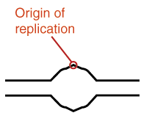

**5’**

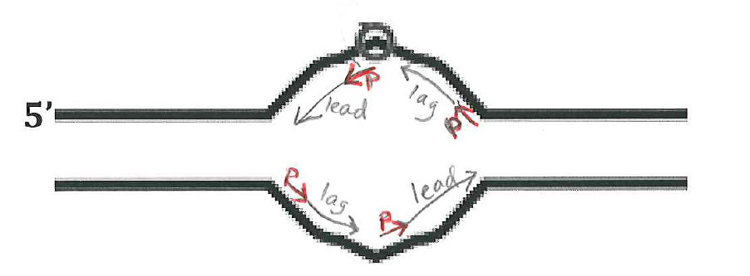

c) Assume the sequence of the top strand of the replication fork, within the replication bubble, is as follows: (the bold, red, underlined nucleotide indicates the center of the origin and corresponds to the position of the red circle in the diagram above:

5’-TTTAGGCCGCT**A**CGTACACTGGG-3’

Write the sequence of the RNA primer (just the first 6 nucleotides) that would be needed to synthesize the leading daughter strand. Your sequence should be recorded 5’ 🡪 3’, regardless of its position on the diagram above. Begin with the nucleotide that would be complementary to the A at the center of the origin.

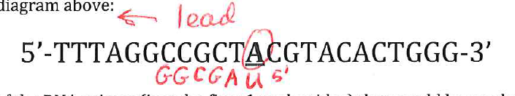

**5’ UAGCGG 3’ 8 points**

**Problem 4(15 points)**

Consider this region of a typical prokaryotic gene:

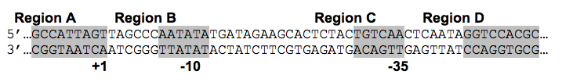

1. Which region of this DNA sequence (A, B, C or D) will be transcribed into RNA? **Region A**
2. Which region(s) are bound by the Sigma70 subunit of RNA polymerase? **B and C**
3. Which strand (top or bottom) will be the CODING strand? **bottom**
4. Give the sequence of the first 8 bases of the transcribed RNA 5’-**ACUAAUGG-3’**
5. Which region(s) are fully “*downstream”* of the promoter? **A only**

**3 points per response. No partial credit.**

**Problem 5 (24 points) Comparing Replication and Transcription**

The following table contains a list of statements that apply to replication, transcription, both, or neither. In each empty box, put an “X” if that statement applies to replication or transcription. (Leaving the box empty implies that this statement does not apply to replication or transcription)

|  |  |  |
| --- | --- | --- |
|  | Replication | Transcription |
| 1. Synthesis of the new strand is initiated at a promoter. |  |  |
| 2. An RNA primer is required to initiate synthesis. |  |  |
| 3. The synthesis of a new strand it initiated at the origin. |  |  |
| 4. The new strand is complementary to the template strand. |  |  |
| 5. The template strand is RNA. |  |  |
| 7. The product is RNA. |  |  |
| 8. The new strand is made 3′ to 5′. |  |  |
| 9. The new strand is made 5′ to 3′. |  |  |
| 10. The process is done only during the S-phase of the cell cycle. |  |  |
| 11. The synthesis product contains uracil |  |  |
| 12. Synthesis is bi-directional |  |  |

Answer:

**1 point per box.**

|  |  |  |
| --- | --- | --- |
|  | Replication | Transcription |
| 1. Synthesis of the new strand is initiated at a promoter. |  | X |
| 2. An RNA primer is required to initiate synthesis. | X |  |
| 3. The synthesis of a new strand is initiated at the origin. | X |  |
| 4. The new strand is complementary to the template strand. | X | X |
| 5. The template strand is RNA. |  |  |
| 7. The product is RNA. |  | X |
| 8. The new strand is made 3′ to 5′. |  |  |
| 9. The new strand is made 5′ to 3′. | X | X |
| 10. The process is done only during the S-phase of the cell cycle. | X |  |
| 11. The synthesis product contains uracil |  | X |
| 12. Synthesis is bi-directional | X |  |